Proposal for ILIAS JRA3:
cryogenics versus vibration
[I3-FP7 call]
Ettore Majorana
Abstract
The reduction of thermal noise in solids is a basic requirement in many kinds of detectors involving position or mechanical energy measurements. If cryogenics is used other favorable conditions are met as high quality factors or higher thermal conductivity such that the use of cryogenics appear a natural choice. The proposed activity is targeted to the leading feature of underground detectors.

1 - Goal motivation and outline of the R&D.

The goal of this research line is to develop specific cryostats equipped advanced cryogenic techniques. At present Pulse-Tube cryo-generators are the best candidates for such applications.

In order to evade the mechanical disturbance induced by the pulse tube on the cold finger, connected to the thermal load to be cooled down, a specifically designed cryostat, equipped with a control system, can be developed.
This activity is intrinsically and naturally interlaced with that of developing suitable cryogenic position and acceleration sensors that must be reliable at LF control (0-5 Hz).

The project VFC, standing for Vibration-Free Cryostat has been financed by ILIAS FP6 and an experimental apparatus has been designed and set-up in such a context.

During 2006-2008 INFN-V (Italian National Institute for Nuclear Physics) provided financial support to allow a partial redesign of the cryostat and suitable maintenance of the activity. However, due to the lack of manpower fully dedicated to this activity and travelling budget, meant to exploit the strategic potential of this research did not establish the conditions to apply for an funding extension within INFN context, while it fits properly ILIAS-JRA targets.

If the VFC activity will be pursued under the auspices of ILIAS, we shall coordinate and update it in effective way

- by integrating VFC [4,5] and cryogenic sensor development with running cryogenics R&D projects for gravitational wave detectors [1,2] and
- by studying alternative configurations as vibration self-cancellation using Double-Pulse-Tube systems [6];
- by adapting vibration-free cryo-cooler experience to other astro- particle physics detectors requiring low temperature and quiet environment [7].
- by exploiting pulsed cryo-generation as a test facility to design and develop new sensors for low frequency vibration sensing

2 – Proposal Submitters.

Ettore Majorana ettore.majorana@roma1.infn.it

3 - Promising technology developed so far.

VFC cryostat developed in Rome at the Dep. of Physics of the Rome University is equipped with a mobile cold-finger, that is pulled up and down by an active control system in order to compensate the its vibration caused by the pressure pulse along the pipe connecting the cold head to the cold-finger [4,5].
VFC performance during 2006-2007 reached -40 dB of active attenuation over a bandwidth of 12 Hz. We remark that the pulse main frequency is ~1 Hz [3], but also its harmonics, effective up to ~ 10 Hz, have to be controlled. Recent smart alternative solutions [6] have reached comparable but worse performance (-30 dB).

A relevant implementation to improve the overall mechanical performance was the re-design and implementation of N2 gas-springs that replaced the bundled steel springs (loaded transversally) used to soften PZT active actuation on the cold head.

Recently (fall 2008) the cryostat was re-assembled with the following improvements.

A) Reduction of the pulse disturbance at the origin. The throttle valve was attached to a massive cement pedestal (~200 kg) and separated from the cold head by 1 m-long pressurized pipe. This choice allowed to reduce the cold-finger vibration by further 40%.

B) More rigid cryostat: a new steel-vacuum tank, 8 mm thick (previously Al 6 mm-thick), with more rigid (x 5) steel flange, used mechanical ground for position sensing of the cold-finger. The chamber is also larger than the previous in order to host, in the future, larger apparatuses. Once servoed the system showed not to be affected by the reinjection of mechanical recoil through the control.

C) Bellow allowing vertical dynamics of the cryo-cooler head substituted. The silicone-rubber bellow that allows the movement of the cold-finger by means of PZT actuators was re-designed made of steel in order to prevent air permeation.
D) The design of a vertical accelerometer prototype was completed and it is presently under construction. We remark that reliable cryogenic vertical accelerometers suitable for control purposes in the low frequency range (0.1 - 1 Hz) are not presently commercially available. Once the vertical control of VFC in the new configuration will be fully performed, the test of this device will be crucial for further developments.

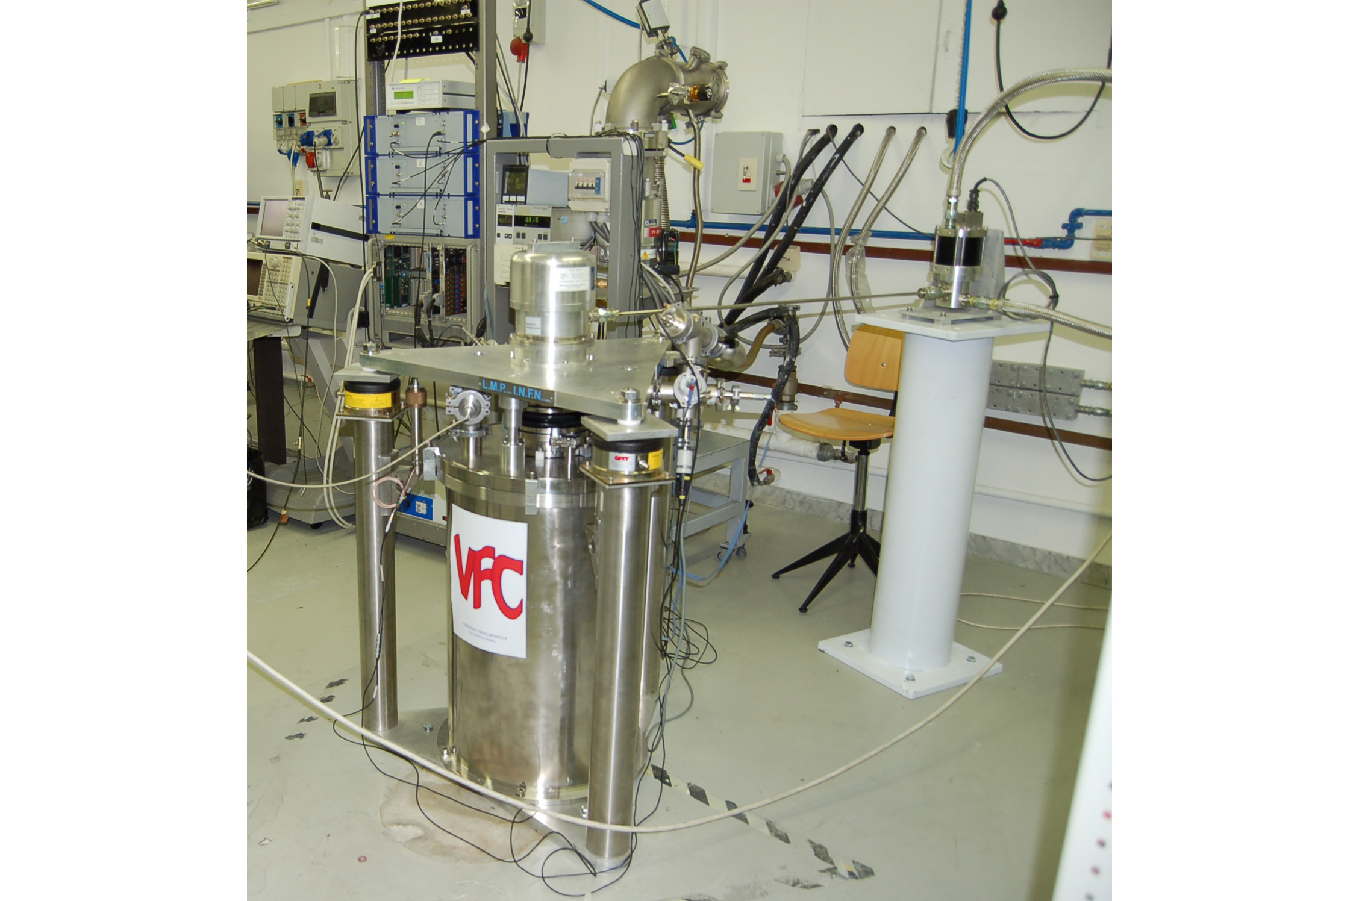
The upgraded version of VFC system setup in the laboratory at Department of Physics at Univ. “La Sapienza” , Rome (December 2008).
4 - Involved People

Researchers INFN
Ettore Majorana
Franco Frasconi
Cristiano Palomba

Researchers University
Fulvio Ricci
Piero Rapagnani
Massimo Bassan

Technicians INFN
Mauro Ciaccafava
Maurizio Perciballi

Subjudice
2 temporary project 4-year-contract

5 – Budget request

personnel-staff | 480000 |  | INFN:1.5FTE*4Y researchers + 1FTE*4Y technicians.
personell-temporary | 200000 |  | 1FTE*4Y
other direct costs | 70000
equipment | 0
consumable | 60000 |  | Cryogenics and cryogenic vibration sensors.
travel&subsistance | 10000
indirect cost | 450000
subcontracting | 0
total budget | 1200000
requested contribution | 720000

6 – References

[1] P. Rapagnani and P. Puppo, “Cryogenic developments for future GW interferometers”, http://www.authorstream.com/Presentation/padapupps-75916-cryogenic-developments-future-gw-interferomet-gravitational-waves-interferometer-cryogenics-puppo-elba-science-technology-ppt-powerpoint/ GWDAW, Elba, Italy, 2008.

[2] K. Kuroda “LCGT Project” http://gw.icrr.u-tokyo.ac.jp:8888/lcgt/

[3] Tomaru T. et al., “Vibration analysis of cryocoolers”, Cryogenics, 44 309-317, 2004.

[4] S. Caparrelli et al. , “Vibration-free cryostat for low-noise applications of a pulse tube cryocooler", Rev. of Sci. Inst. 77 9 095102, 2006.

[5] E. Majorana et al., “Vibration Free Cryostat for cooling suspended mirrors”, Journal of Physics Conference Series 32 374–379, 2006.

[6] Suzuki T. et al., “Pulse tube cryocooler with self-cancellation of cold stage”, http://arxiv.org/abs/physics/0611031v1, Cryo Prague 2006.

[7] R. Ardito et al. “CUORE Collaboration: A cryogenic underground observatory for rare events” http://arxiv.org/abs/hep-ex/0501010 2005.

