“Einstein gravitational wave Telescope design study presentation”.
(May, 20th 2011)

INFORMATION NOTE:
Address/Location Contact Information
Auditorium Marta Budroni tel.: (+39) 050 75 24 76
EGO (European Gravitational Observatory) site (+39) 050 75 25 11
Via E. Amaldi s.n.c e-mail: marta.budroni@ego-gw.it
Cascina (PISA) 56021
Italy

GPS: 42˚ 37’ 48.98” N
10˚ 30’ 07.34” E

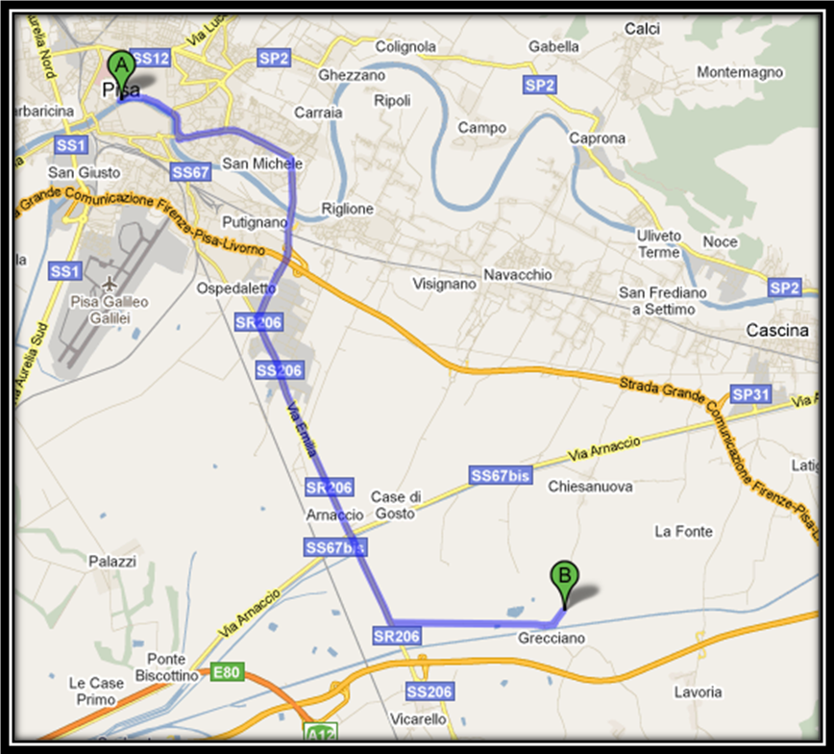

- ACCOMODATION/LODGING
EGO selected the following hotel for the event:

Hotel BOLOGNA
Via Mazzini 57
5125 Pisa (PI)
Website: www.hotelbologna.pisa.it
Tel. (+39) 050 50 21 20

The hotel offers:
- a free shuttle service from/to the airport and Pisa Central Train Station for people who submitted the request. The concerned guests are required to call the hotel
(+39) 050 50 21 20, when they arrive at the Pisa airport/rail station.
- a supervised indoor parking (cost 10,00€) for people who submitted the request. The hotel has been informed about the names of the concerned guests.
- a free access to wireless connection.
- a breakfast buffet service (7:00-10:30).

- TRANSPORTATION (for the hotel Bologna guests)
The shuttle departs from the hotel Bologna to the EGO site at 10:00 am.

The shuttle is available to leave from the EGO site starting from 03:30 pm to reach the Pisa airport/rail station or the hotel Bologna.

- SCHEDULE
10:30 Coffee break

11:00 Welcome talk
11:05 The European Gravitational Observatory
11:15 Gravitational wave search in Europe and in the World
11:35 LIGO detectors: past, present and future
11:55 Virgo and Advanced Virgo
12:15 Visit of the Virgo site

13:00 Lunch

14:30 ET design study: Science Case
15:00 ET design study: the observatory
16:00 Conclusion

- WIRELESS INTERNET AT EGO
Access to wireless connection is free.

